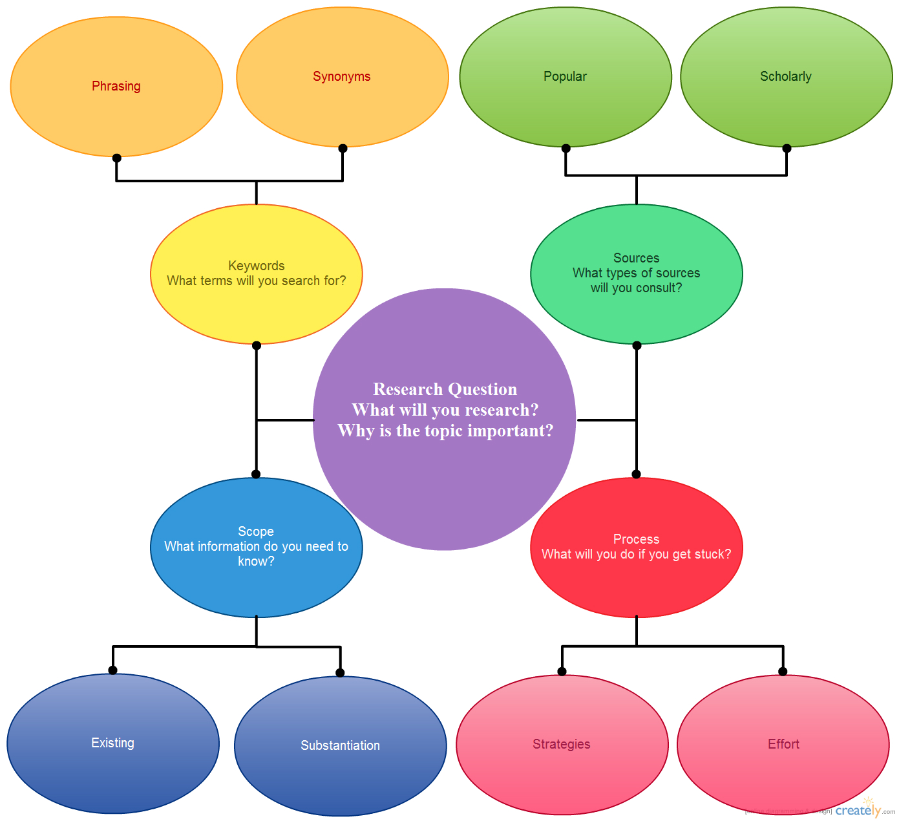

Use this concept map and fill it out for your research topic.
Write your ideas on the map or on a separate piece of paper.

